# Init

* 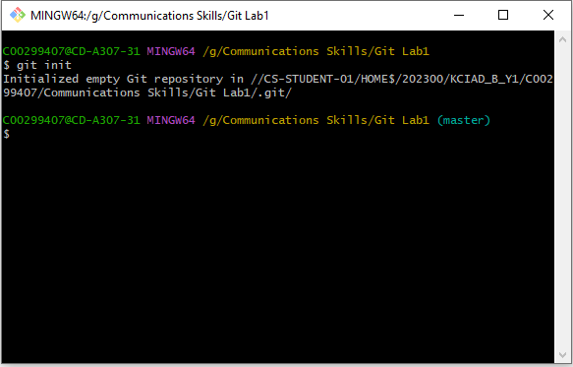Creates a new local repository in a chosen folder.
* Git Bash adds a git. folder to the chosen folder.
* This git bash folder is hidden but can be made visible through clicking “view” and selecting “hidden items”.

